

Muslim.In Stock and Order Inspection

Group 1

Names : Laksamana Zaidan Alfayyadh

Ravi Haryo Baskoro

Class : 3SC5

CEP CCIT

FAKULTAS TEKNIK UNIVERSITAS INDONESIA

2020

**PROJECT ON**

Muslim.In Stock and Order Inspection

**Developed by**

1. **Laksamana Zaidan Alfayyadh**
2. **Ravi Haryo Baskoro**



Muslim.In Stock and Order Inspection

Batch Code : 3SC5

Start Date : October 14th 2020   
End Date : October 27th 2020

Name of Faculty : Muhammad Idham Khalif

Names of Developer :

1. Laksamana Zaidan Alfayyadh
2. Ravi Haryo Baskoro

Date of Submission: October 26th 2020

**CERTIFICATE**

This is to certify that this report titled “Muslim.in” embodies the original work done by Laksamana Zaidan Alfayyadh and Ravi Haryo Baskoro. Project in partial fulfillment of their course requirement at NIIT.

Coordinator:

Mhd. Idham Khalif



**ACKNOWLEDGEMENT**

First of all, we would like to thank God because of His blessings and guidance, writers can compose and present a paper that contains about Muslim.in. Writers also thanked to Mr. Mhd Idham Khalif as lecturer that have provided guidance to the writer in the process of preparing this paper. Not to forget the writers thank the various parties who have given encouragement and motivation

The authors realize that the preparation of this project there are still many shortcomings and far from being perfect. Therefore, the authors expect constructive criticism and suggestion to improve this paper and can be reference in preparing the papers or subsequent tasks.

The authors also apologize if in writing this paper there are typos and errors that confuse the reader in understanding the authors’ intent.

Jakarta, October 25, 2020

Authors

**SYSTEM ANALYSIS**

**System Summary**:

In this project, we created a website that displays stock details of goods available in the store. First, the user must register an account first to gain access to the web. After registering, must be logged in based on the registered account. Then, the user can see the stock of goods displayed on the web. for stock settings of goods, we create a web to create, read, update, and delete the data. The data will then be connected to the web for the user.

**DATABASE DESIGN**

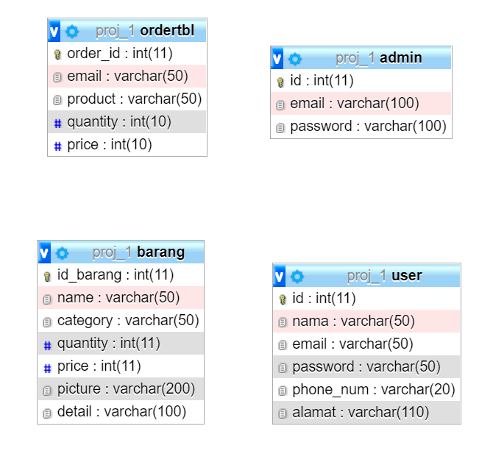

\

sssssssssss

**TABLE DESIGN**

1. User Table

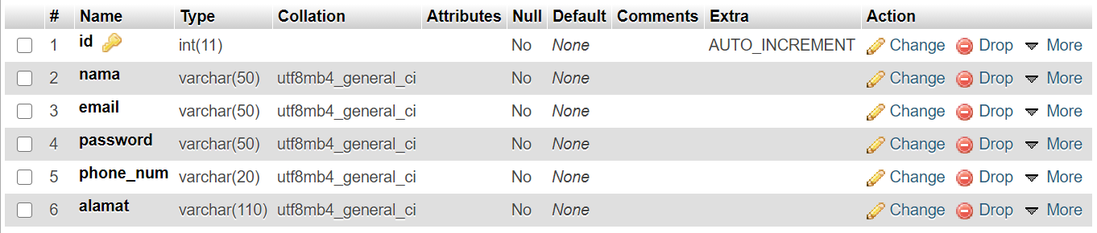

1. Product Table

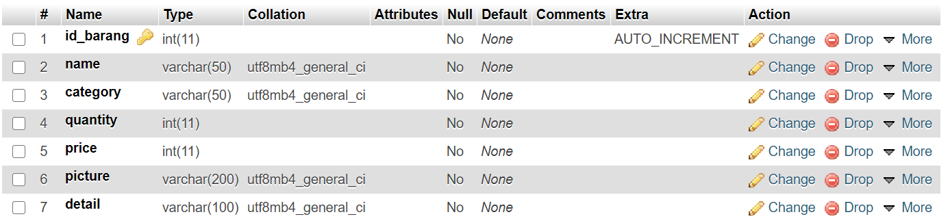

1. Order Table

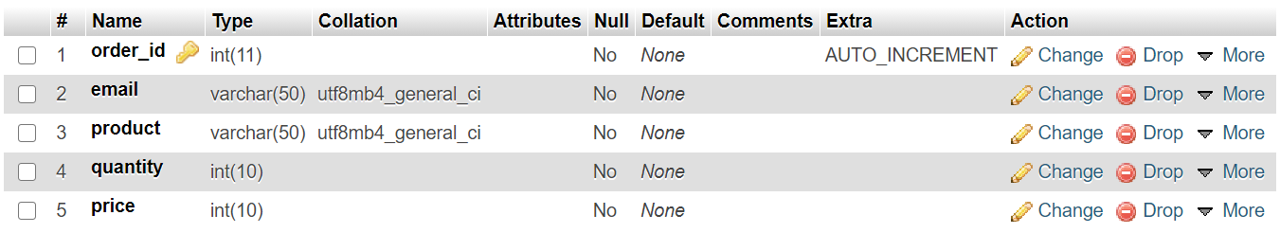

1. Admin Table

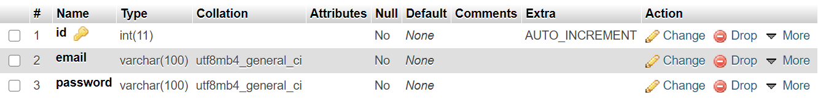

1. **User Interfaces**
2. Login Form

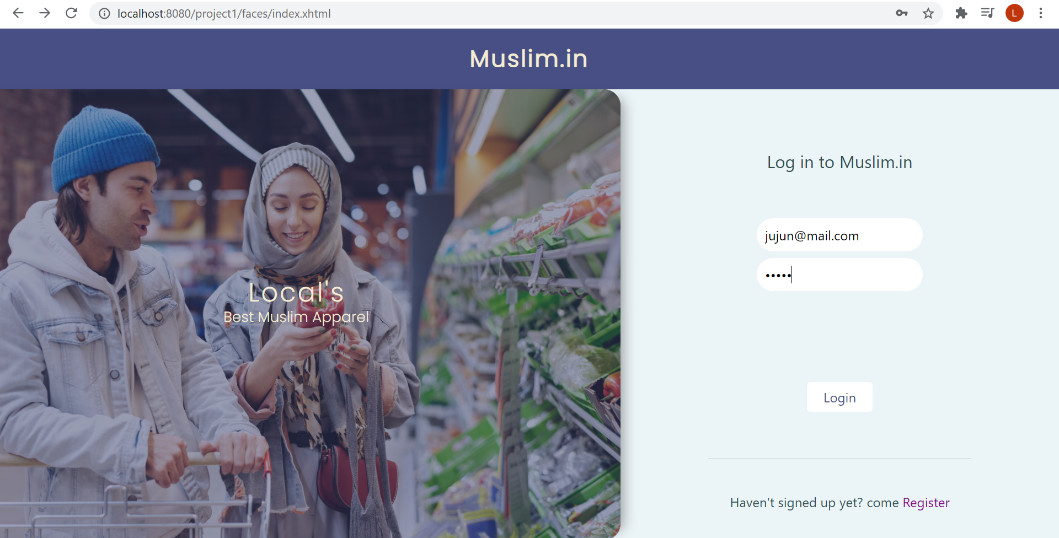

1. Registration form

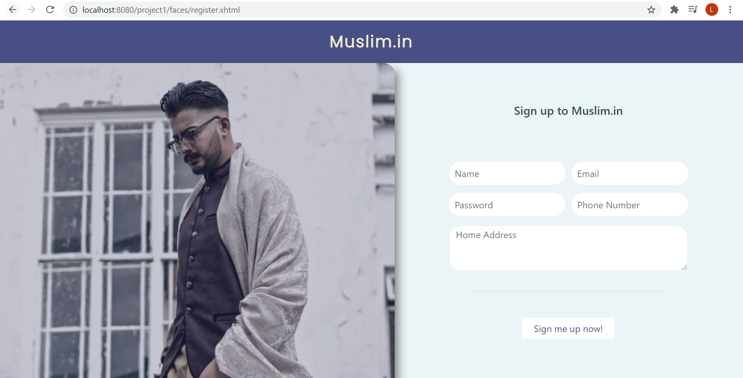

**USER INTERFACE**

c. Home Page

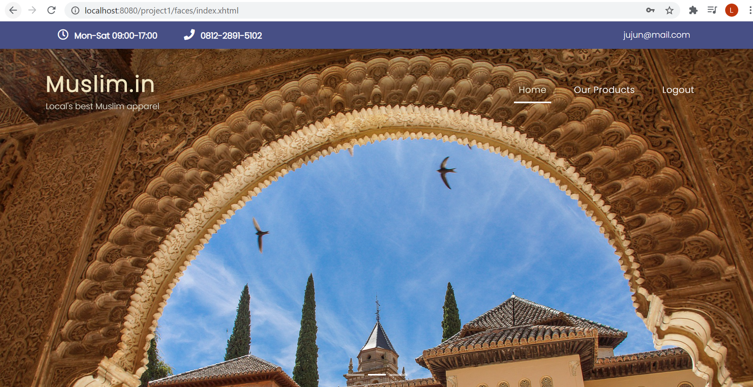

d. Products Page

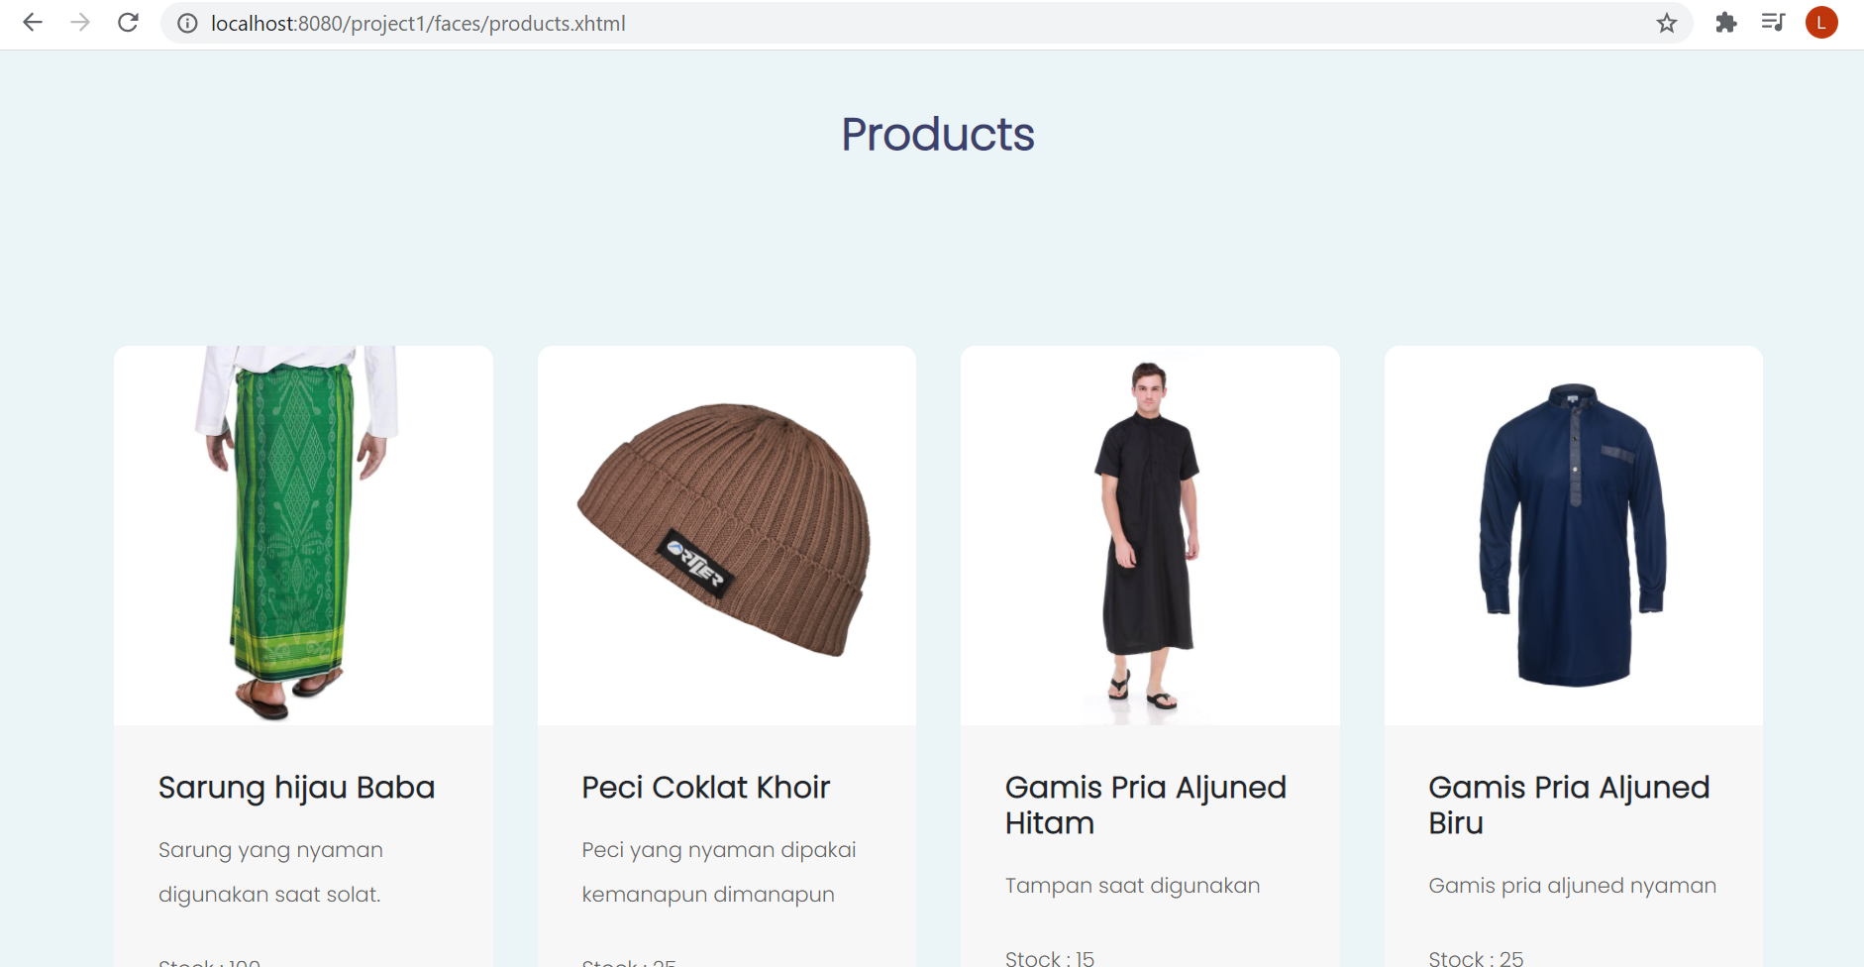

**USER INTERFACE**

**2. Admin User Interfaces**

a. Admin Login Page

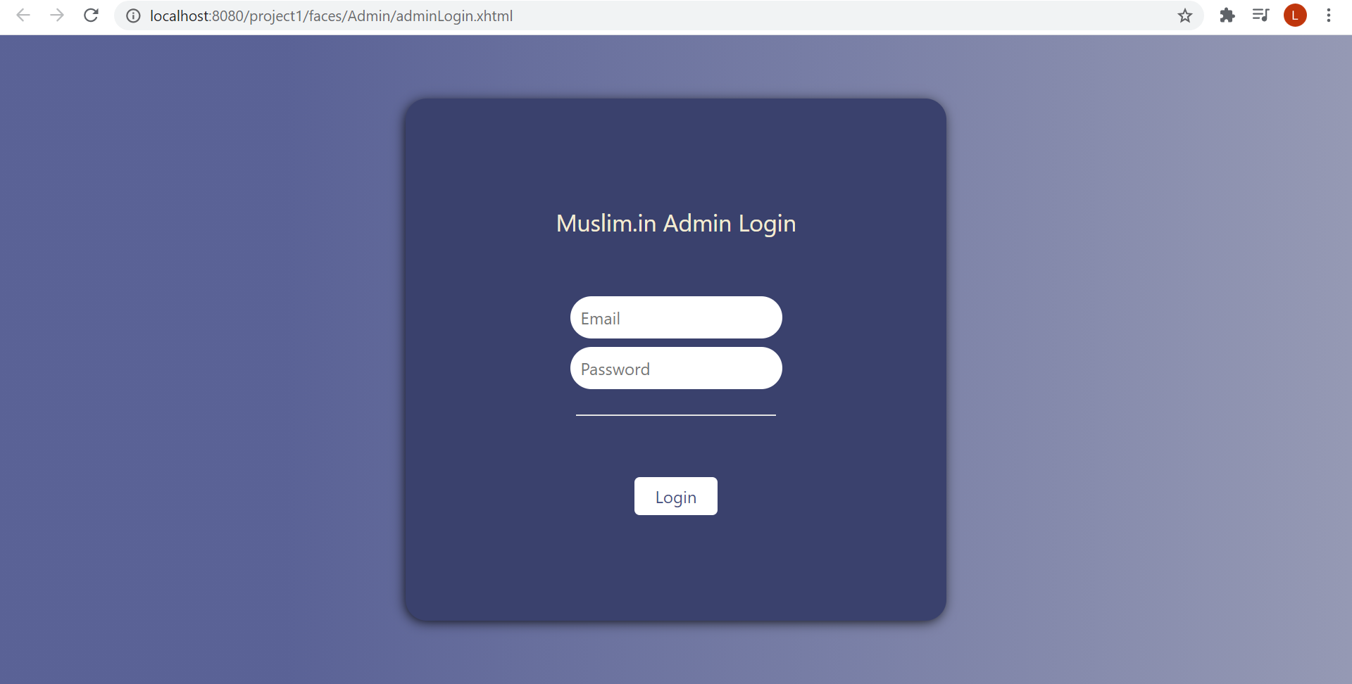

b. Product List Page

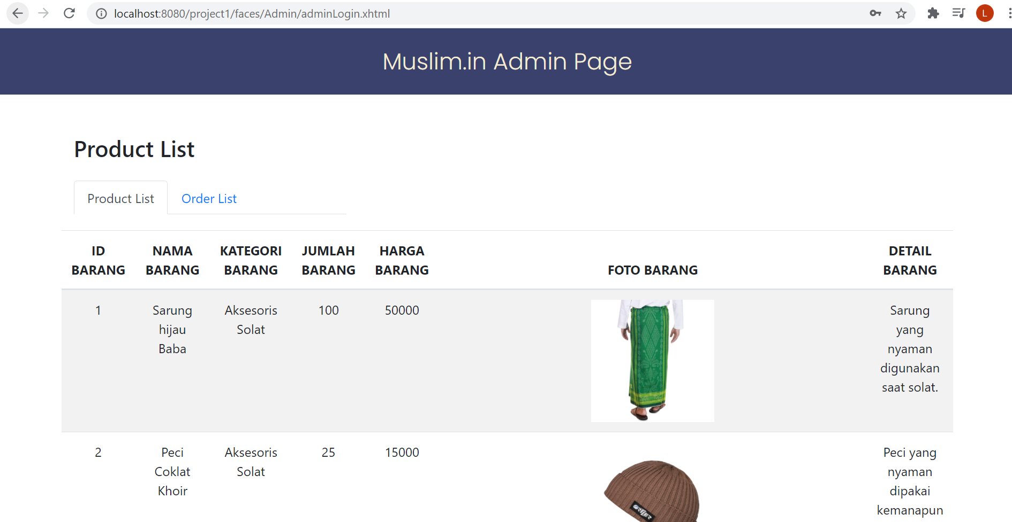

**USER INTERFACE**

c. Product List Page (Footer)

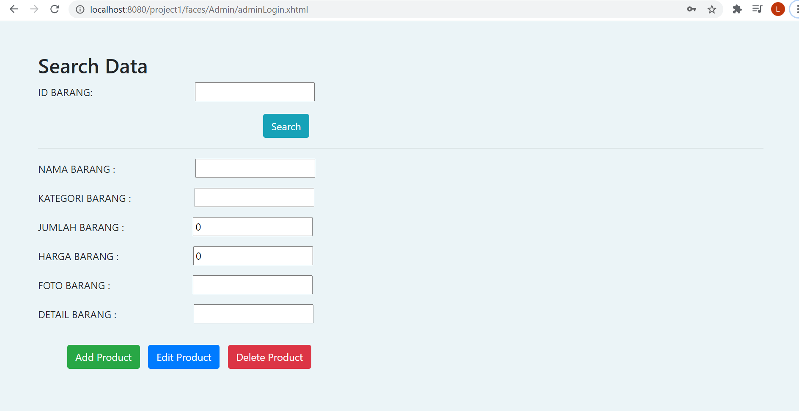

d. Order List Page

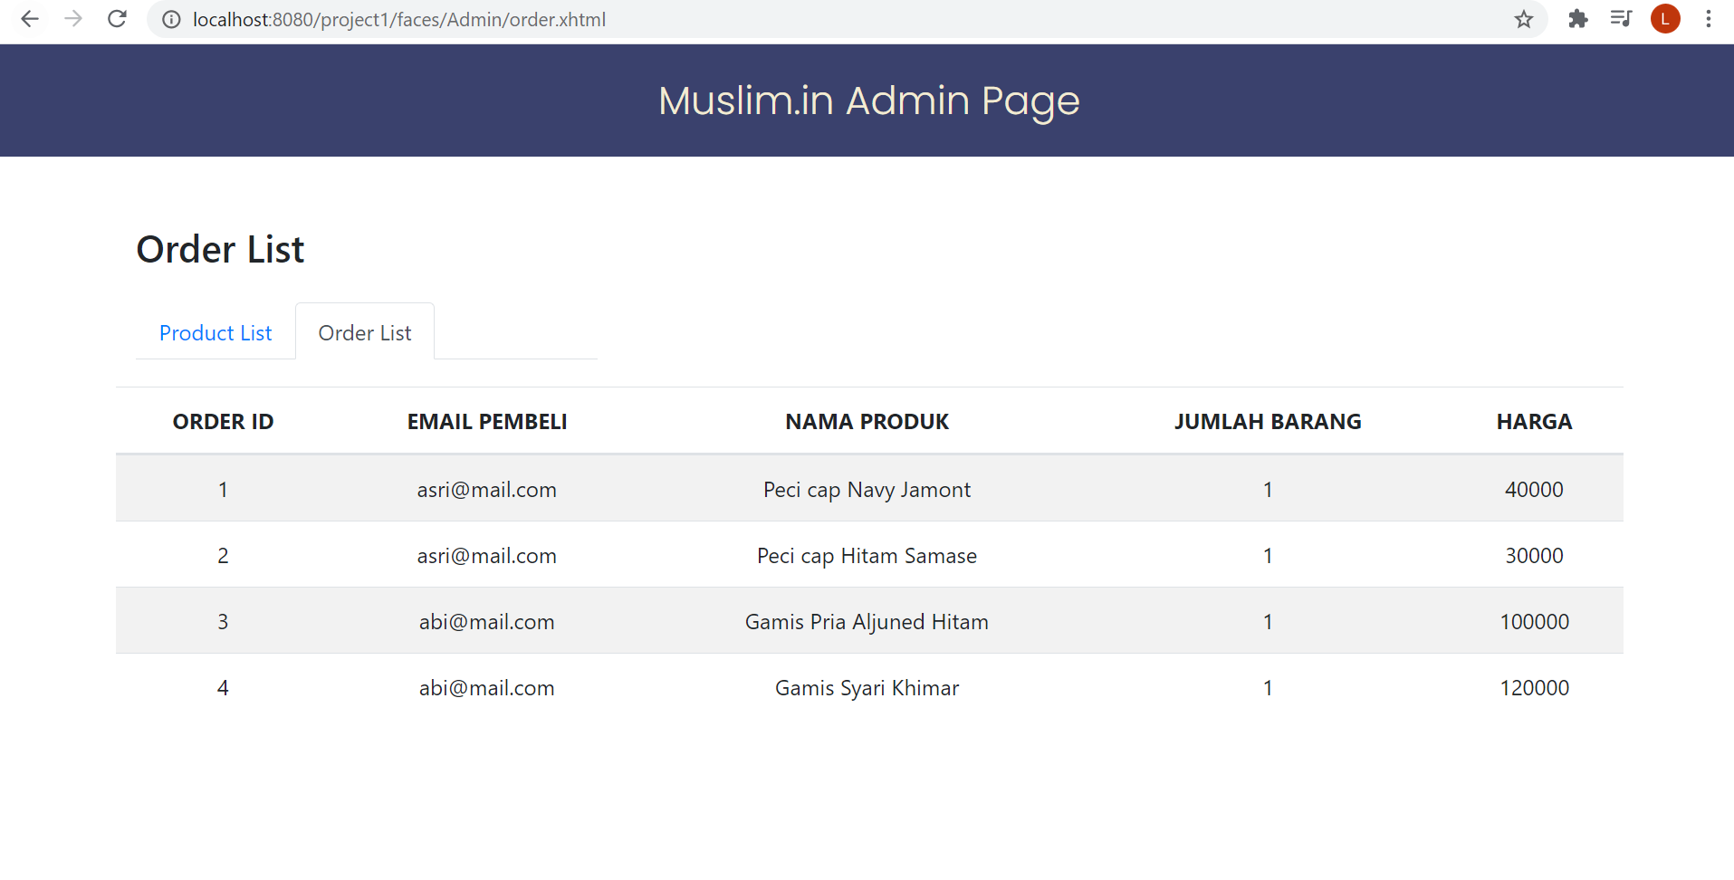

**USER INTERFACE**

**CONFIGURATION**

**Hardware :** Intel Core i7 HP-PC

**Operating System : Windows 10**

**Software :**  Netbeans IDE 8.0.2, XAMPP, Google Chrome

|  |  |  |
| --- | --- | --- |
| **PROJECT FILE DETAILS** | | |
| **S.No** | **File Name** | **Remarks** |
| 1 | Project1 | Netbeans file that contains Web’s code |
| 2 | Muslim.in Stock and Order Inspection.docx | Word file of project;s database design, table design, and user interface |
| 3 | LinkYoutube.txt | Contains the project’s video presentation |
| 4 | proj_1.sql | Sql query file of project’s database |
| 5 | Muslim.in.pptx | Power Point of this project |

\

sssssssssss